CAS PY 106

Prelecture Note 28

1. Refraction
2. Change in direction that occurs when light passes from one medium to another
3. Index of refraction
4. When an EM wave travels in a vacuum its speed is: c = 3.00 \* 108 m/s
5. In any other medium, light generally travels slower
6. The speed of light v in a material depends on the index of refraction, n, which is the ratio of the speed of light in vacuum to the speed of light in the medium
7. Index of refraction: n = c/v
8. We expect n >= 1
9. When light travels from one medium to another, the speed and the wavelength change, but the frequency remains the same.
10. The index of refraction can be stated in terms of wavelength
11. Index of refraction: n = c/v = f \* wavelength/ (f \* wavelength’) = wavelength / wavelength’

Where wavelength 🡪 wavelength in vacuum,

Wavelength’ 🡪 wavelength in the medium

1. 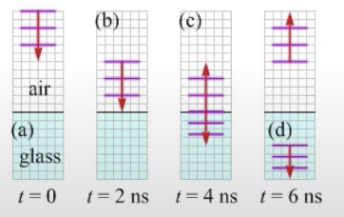
2. Wavelength in the medium is smaller than the wavelength in vacuum
3. Rays and wavefronts
4. We will keep using our simple ray model of light, and add wavefronts to it to extend the usefulness of the model
5. The rays are the red arrows in the diagram, and the wavefronts (in purple) show, for example, the peaks in the waves
6. 
7. Sample values of n
8. 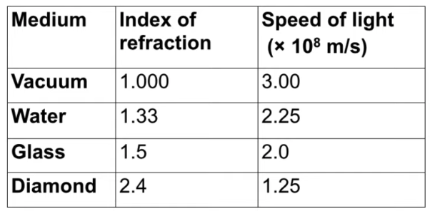
9. A simple model of light changing medium
10. Imagine a marching band marching at a steady speed across a paved parking lot
11. When they reach the edge of the parking lot they keep going into a grassy field, but they slowdown in the grass
12. If the rows of the marching band are parallel to the interface, the rows get closer together when the band crosses over to the grass.
13. The decrease in speed causes a decrease in wavelength
14. 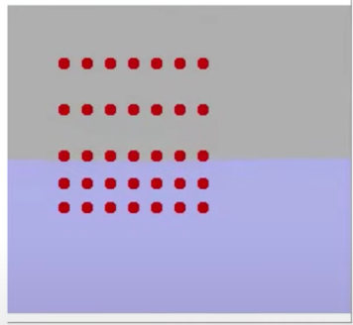 🡪 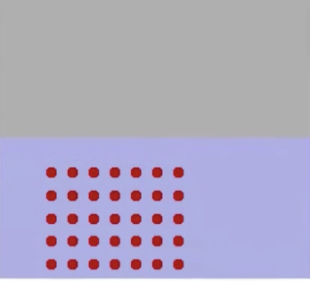
15. If the lines of the marching band are not parallel to the interface there is only a decrease in wavelength but also a change in direction of the wave
16. The change in direction, caused by the change in wave speed, is known as refraction
17. 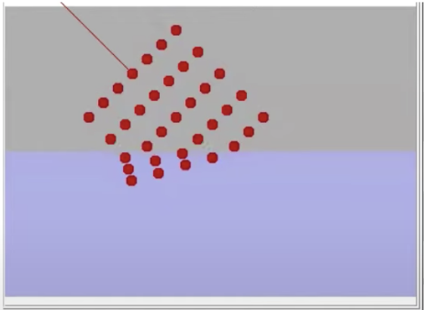🡪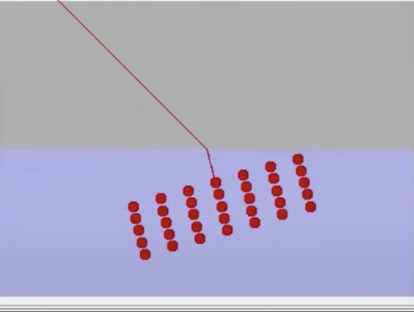
18. Snell’s Law
19. When a ray of light encounters an interface between two media, two things generally happen:

* First, some of the light reflects off the interface (the law of reflection applies)
* Second, some of the light refracts into the second medium

1. 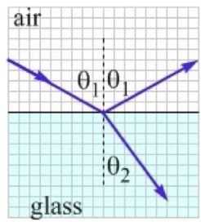
2. The angle of refraction theta 2 (the angle in the second medium) is related to the angle of incidence theta 1 by

Snell’s Law: n1\*sin(theta1) = n2 \* sin(theta2)

N1 is the index of refraction of the first medium and n2 is the index of refraction of the second medium.

Angles are measured from the normal, which is the line perpendicular to the interface

1. Toward/away from the normal
2. When light crosses an interface into a medium with a higher index of refraction, the light bends toward the normal (low index of medium to high index of medium 🡪 fast medium to a slow medium)
3. 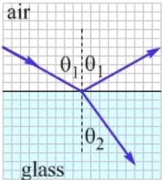
4. Conversely, light traveling across an interface from higher n to lower n will bend away from the normal (high end medium to low end medium)
5. 